**API Request Documentation:**

First click on the below icon



Next enable the Api option

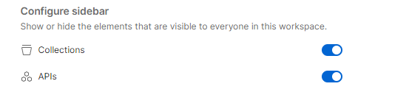

Then we can see the icons as given below

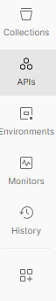

In api there is option collection and add collection

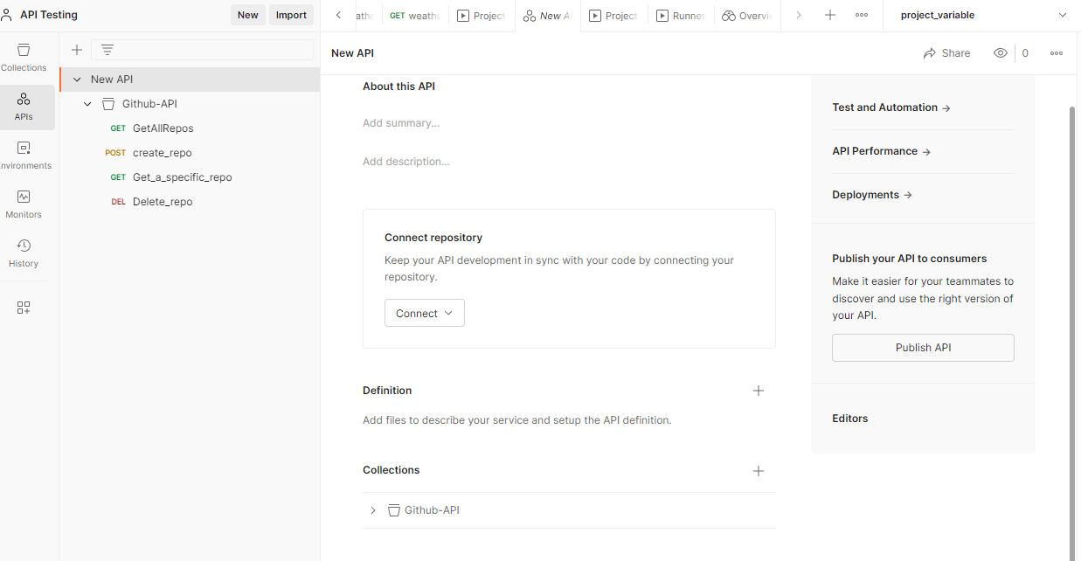

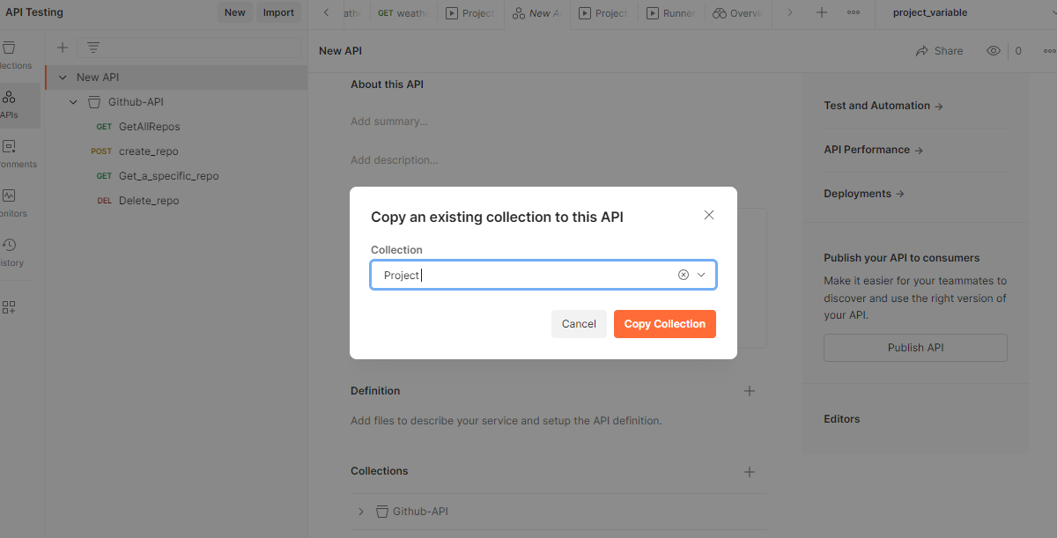

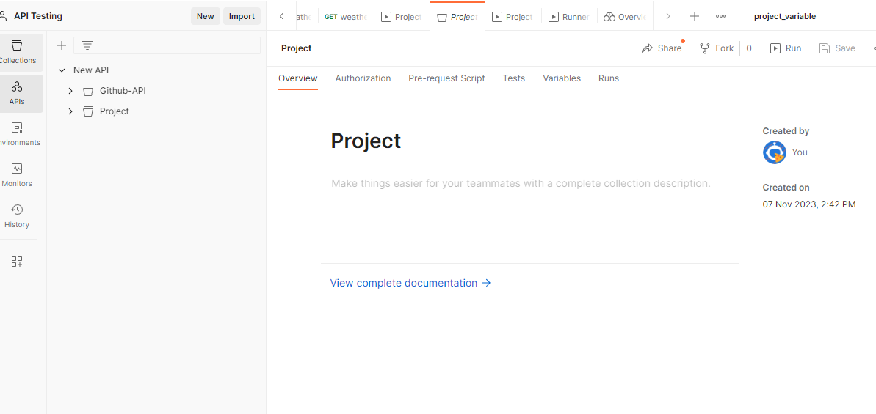

Click on view document we can see the document,as given below.

